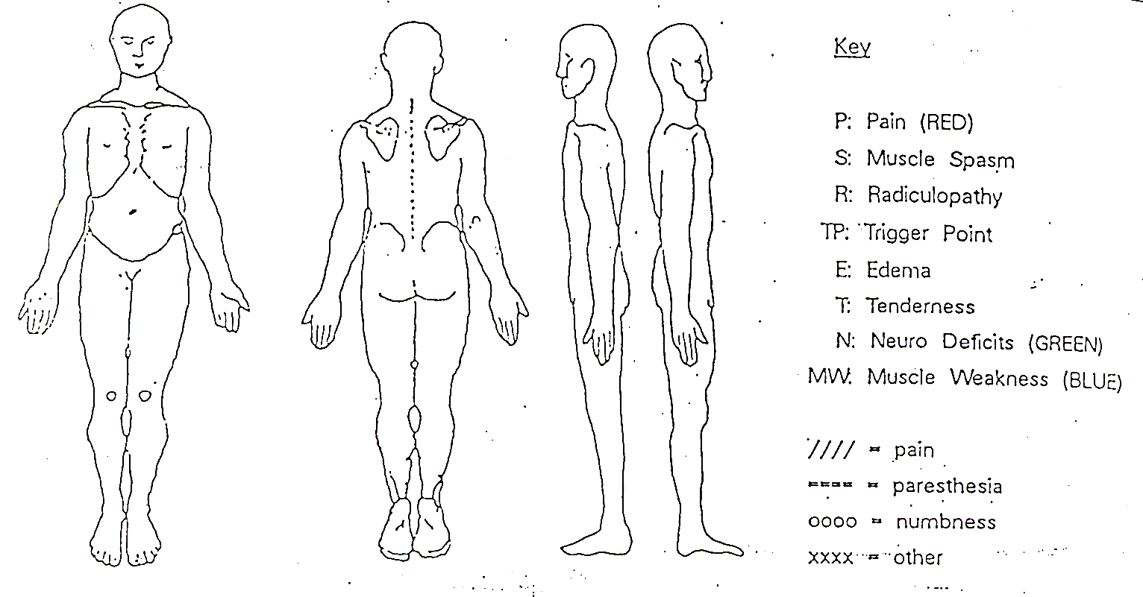
Mark on the picture below where your symptoms are located :

What is the main problem/ chief complaint that you are seeking physical therapy for?_______________
_____________________________________________________________________________________
_____________________________________________________________________________________
_____________________________________________________________________________________
_____________________________________________________________________________________

Please list ALL medications you take for ANY condition: ______________________________________
_____________________________________________________________________________________
_____________________________________________________________________________________
_____________________________________________________________________________________
_____________________________________________________________________________________

Please list ANY & ALL medical conditions, other than what we will be treating you for: _____________________________________________________________________________________
_____________________________________________________________________________________
_____________________________________________________________________________________

